Experiment 27:
Aim:
27.Write a Python programming to display a bar chart of the popularity of programming Languages.
Python code:
import matplotlib.pyplot as plt

# Data
languages = ['Java', 'Python', 'PHP', 'JavaScript', 'C#', 'C++']
popularity = [22.2, 17.6, 8.8, 8, 7.7, 6.7]

# Create bar chart
plt.bar(languages, popularity, color='skyblue')

# Add labels and title
plt.xlabel('Programming Language')
plt.ylabel('Popularity (%)')
plt.title('Popularity of Programming Languages')

plt.show()
Output:
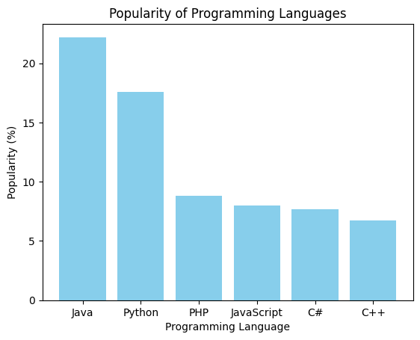
Experiment 28:
Aim:
28.Write a Python programming to display a horizontal bar chart of the popularity of programming Languages.
Python code:
import matplotlib.pyplot as plt

# Data
languages = ['Java', 'Python', 'PHP', 'JavaScript', 'C#', 'C++']
popularity = [22.2, 17.6, 8.8, 8, 7.7, 6.7]

# Create horizontal bar chart
plt.barh(languages, popularity, color='salmon')

# Add labels and title
plt.xlabel('Popularity (%)')
plt.ylabel('Programming Language')
plt.title('Popularity of Programming Languages')

plt.show()
Output:
